Order of Operations: PEMDAS Guided Notes

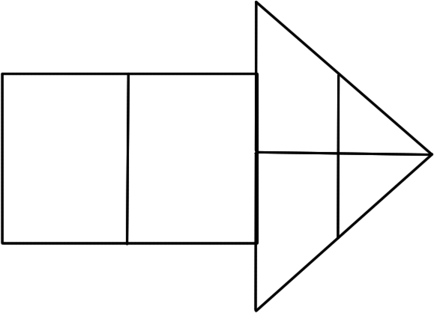

parenthesis
braces
brackets

Please (__________________) or groupings: ( ), [ ], { }
Excuse ____________________: y³
My Dear __________________________________, (same rank, left to right)
Aunt Sally __________________________________, (same rank, left to right)

In mathematics and computer programming, the order of operations (PEMDAS) is a rule used to clarify which procedures should be performed first in a given mathematical expression.
PEMDAS Practice Problems Name: ________________________________________________
Exponents and Order of Operations Date: ____________________ Core: _________________
Instructions: Solve each mathematical expression using the order of operations (PEMDAS) rule.
1. 30 – 18 $÷$ 6 $*$ 4 2. 5² $÷$ 5 (5 – 3)

3. 6² + 3 $*$ 7 – 4 + 8 4. 45 – 2(2⁵ $÷$ 8)²

5. 3 + [(3 + 3)² – 7] $÷$ 2 6. 3 + 4 $÷$ 2(6 – 4)³

7. 18 + 5 – 4 + 9 $÷$ 3 – 4 8. (45 $÷$ 9 $*$ 8 $÷$40)⁵

9. ${\frac{(18-6)}{(3 *4)}}^{2}$ $*$ 12

10. Demarcus earns $18/hr., Rufus earns $17/hr., Marissa earns $17/hr., and Juanita earns 16/hr. performing various tasks at the Triangle Mall. These four friends need $1200 combined to pay for their four airline tickets from RDU International to Daytona Beach for Spring Break. If the boys work 15 hours and the girls work 20 hours will that be enough to pay for the tickets? Write a numerical expression for this problem and solve.

11. Jose flew a round trip (back and forth) to Oakland from Raleigh, which was 5,600 miles, and Anita’s round trip to Dallas from Raleigh was 2,400 miles. What was the difference between flights just going one way (from RDU to their destination)?

